MyFashionCorp

1. Definition:  
   I have been asked to create a new cart page for MyFashionCorp.  
   They ask me to research all the required services and present the outcome to the team.  
     
     
   Graphical user interface, application, website

   Description automatically generated
2. Components:  
   I split the page to multiple components and highlighted them  
   each component will have one or more API.  
     
   Graphical user interface, website

   Description automatically generated
3. Swagger:  
   I create a swagger file to document the API and facilitate the integration between frontend and backend.  
     
   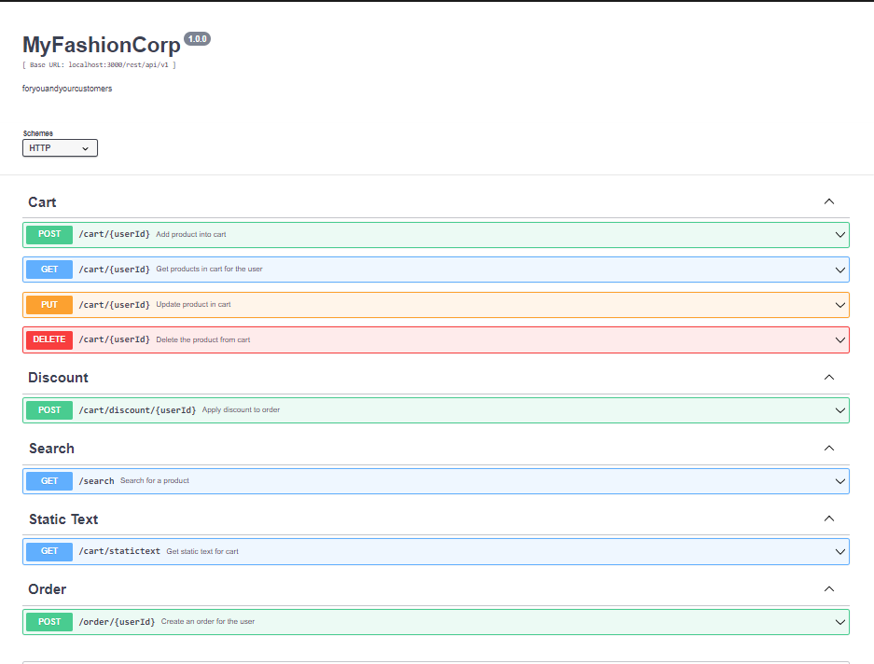
4. Flow Details and explanation:   
   * **POST: /cart/{userId}**  
     When user want to add a product in cart, we will use this API to add the product to cart using the userId.
   * **GET**: **/cart/{userId}**

We would use it to get all products in cart for user and display in the previous page.

* + **PUT**: **/cart/{userId}**

We would use it to update the product in the card, like if we increased the quantity or decreased it.

* + **DELETE**: **/cart/{userId}**

We would use it to update the product in the card, like if we increased the quantity or decreased it.

* + **POST**: **/cart/discount/{userId}**

To apply a discount to order total we would use this API, it will take the discount code then in back end:  
 - Get the value of discount.  
 - Get subtotal for all products in cart using userId.  
 - Calculate total by using the subtotal minus discount and rebates

and plus shipping costs.

* + **POST**: **/order/{userId}**To create the order we would use this API and in backend will we do  
     - Calculate discount if code exists using previous functionality in /car/discount/{userId.  
    - Create the order in our db.
  + **GET: /search**   
    Search for the product to add into cart.
  + **GET: /cart/statictext**  
    To get static texts in the page.